**What are reports in Jenkins?**

Reports are basically the structured as well as a graphical way to produce the execution results of tests. As we discussed in the introductory part we generate reports so that higher management, stakeholders as well as other team members who have less technical knowledge can also easily understand the success ratio of our scripts, and based on that, they can analyze the quality of our test scripts as well as product.

In Jenkins's perspective, different formats of reports are available. It depends on us in which format we want to publish our results. These reports can be *graphical, tabular, or in other detailed formats.* The *Jenkins reporting capabilities* majorly depend on third-party plugins. So, we will need to install and configure a compatible plugin for the same whatever the report's expected format. Let's quickly see how we can integrate and view *JUnit reports in Jenkins:*

***How to Publish JUnit report in Jenkins?***

In this section, we will see that how to publish *JUnit test result reports in Jenkins.* Please follow the below steps to achieve this part:

***Step 1:*** Before moving to further action, please ensure that ***JUnit Plugin*** is properly installed in the Jenkins machine. By default, it is automatically installed in *Jenkins,* but then we can go to ***Plugin Manager*** and install it if it is not installed. Once it is installed, then it will be displayed under the installed tab like the below image:

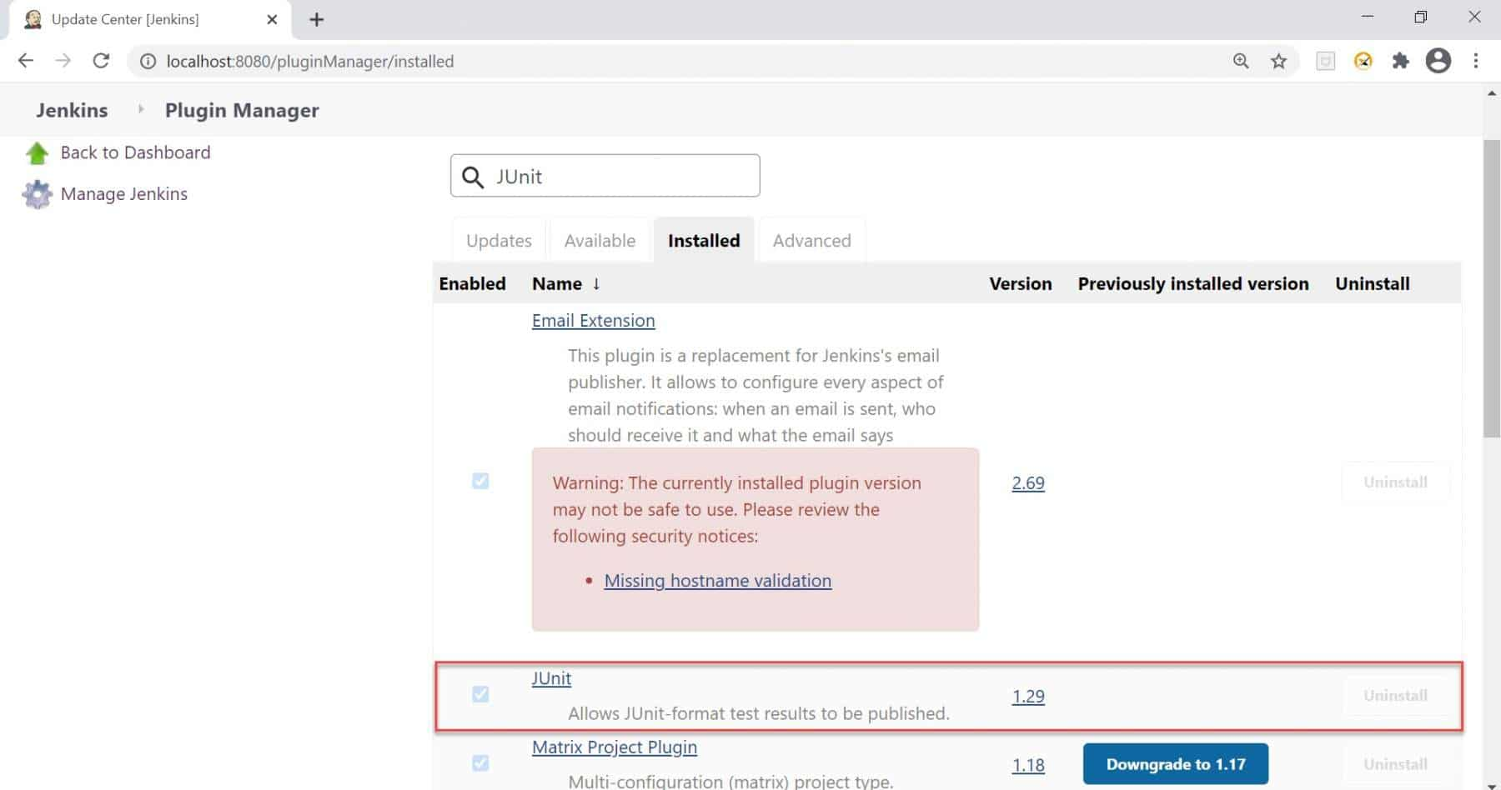

***Step 2:*** For publishing the Junit report, let's take the example of the freestyle project. I created the project as ***"Test_Junit_Report",*** as shown in the below image:

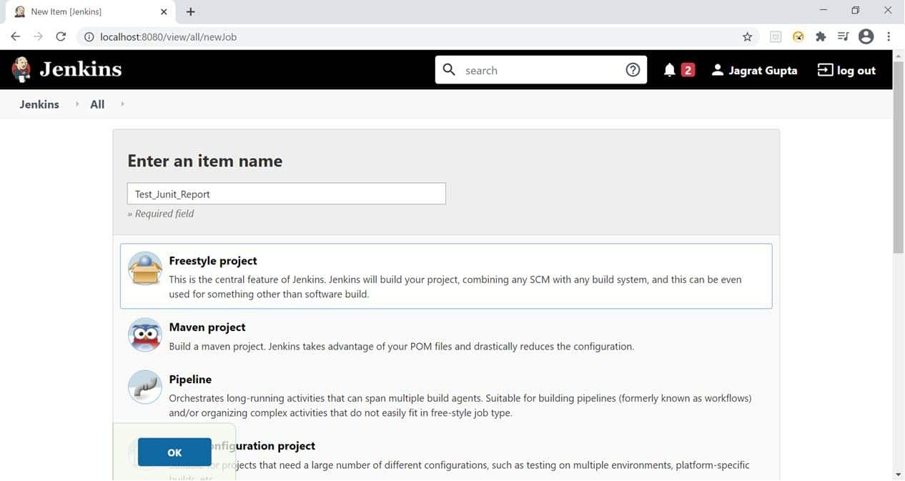

***Step 3:*** Now, go to configure section and Put the description of the project and the GitHub Project URL as we put our script in GitHub. Please find the GitHub repository URL  [***https://github.com/toolsqa17061989/SetupBuildJob/.***

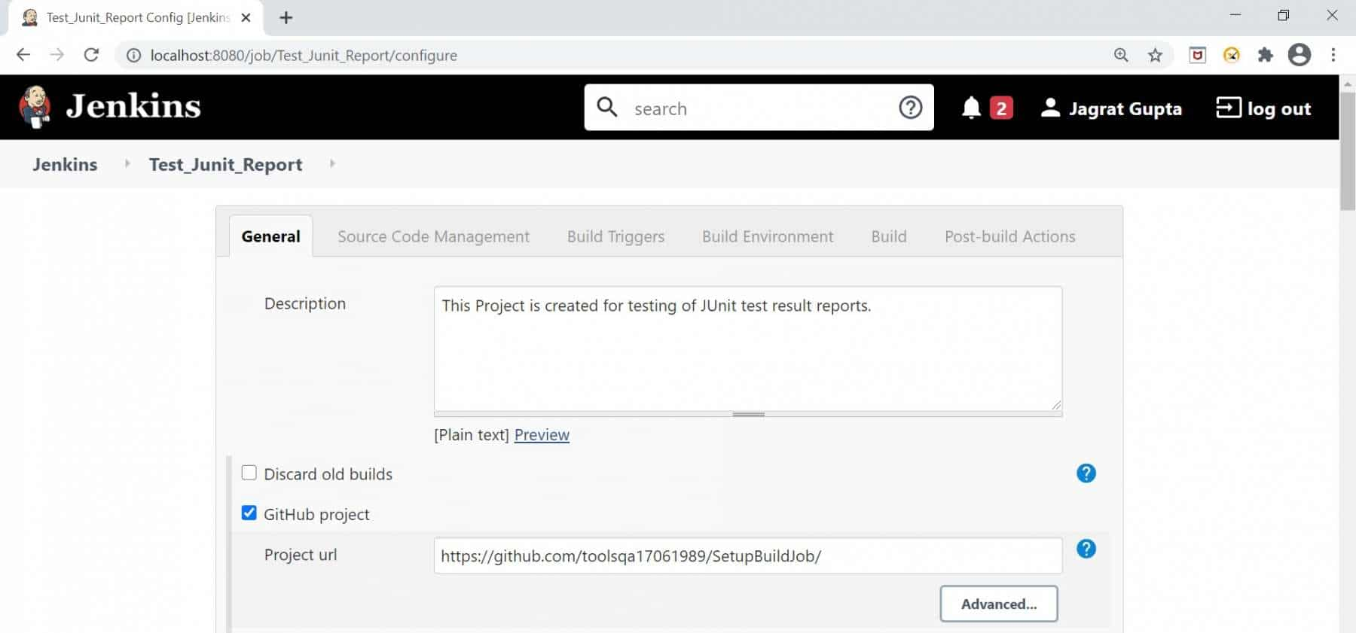

***Step 4:*** Go to the ***Source Code Management*** section and put the repository URL mentioned in the below image.

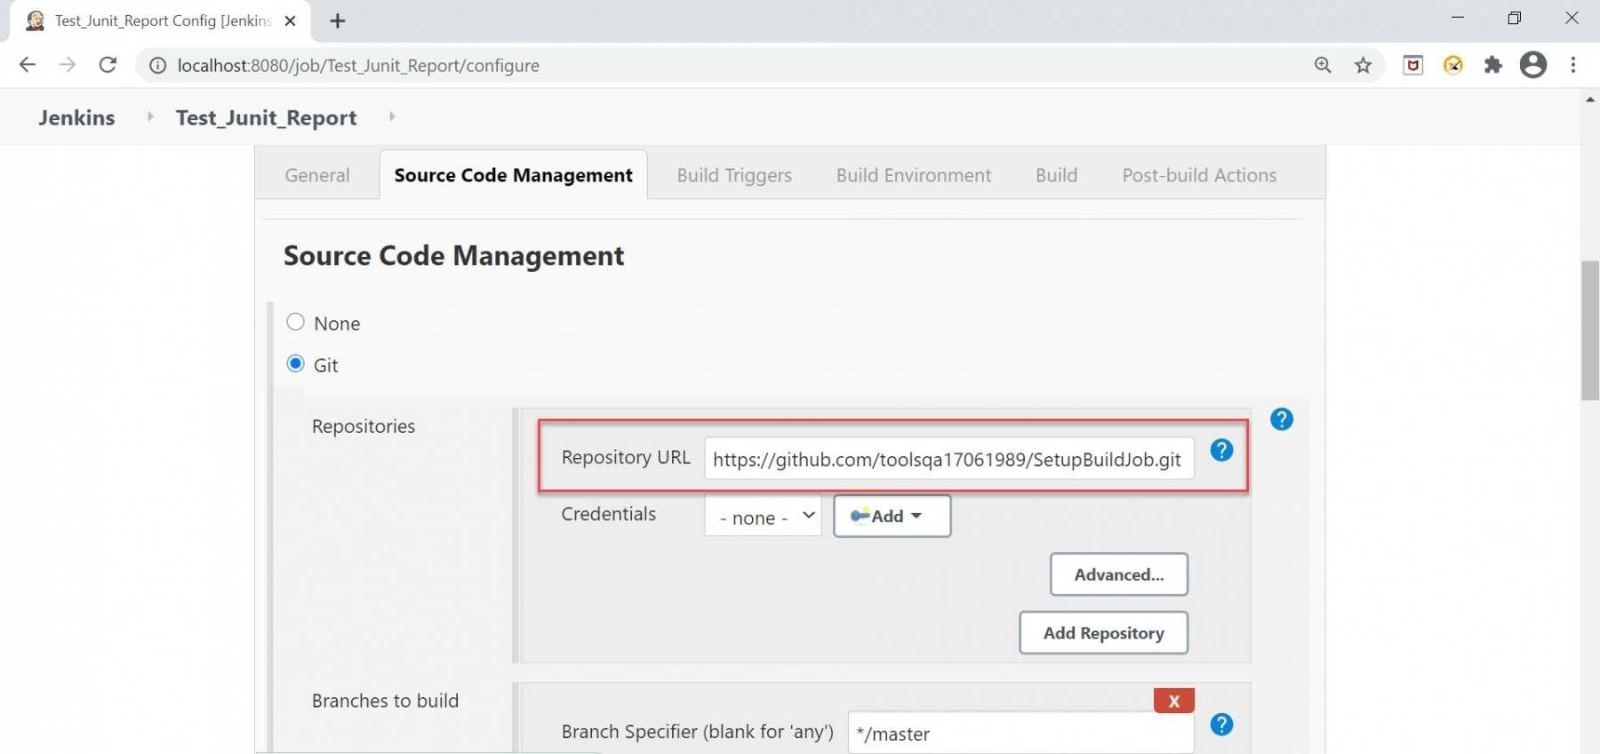

***Step 5:*** Now, go to the ***Build***  section and do the following steps:

* *Click on the****"Add Build Step"****dropdown.*
* *Select option****"Invoke top-level Maven targets".***
* *In the Goal textbox, write the command like****"clean compile test".***
* *Click on the Save button.*

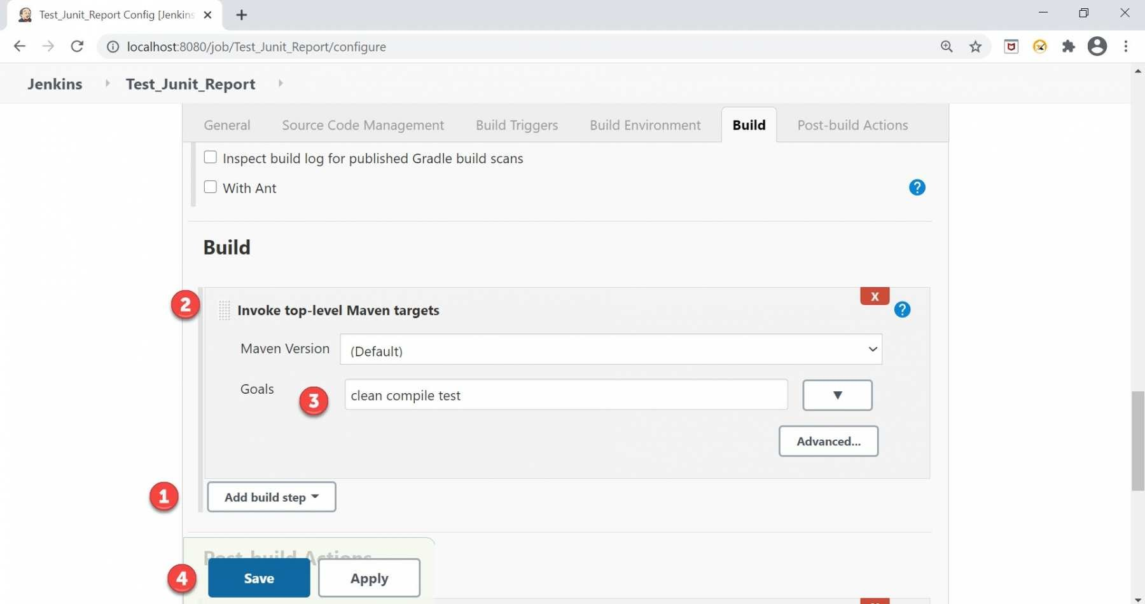

***Step 6:*** Now run the build to check whether the build result is successful or not. After running successfully, go to the job and click on the ***"Workspace"***  link.

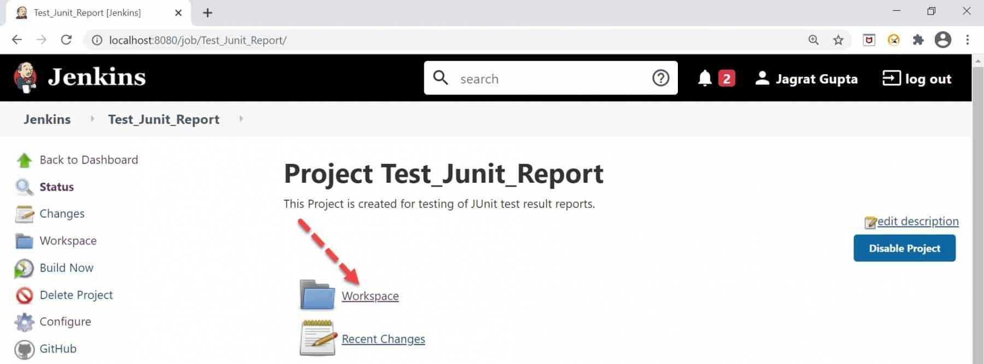

As soon as we click on the above-mentioned link, we will be inside this directory. Now click on the ***"target"*** link.

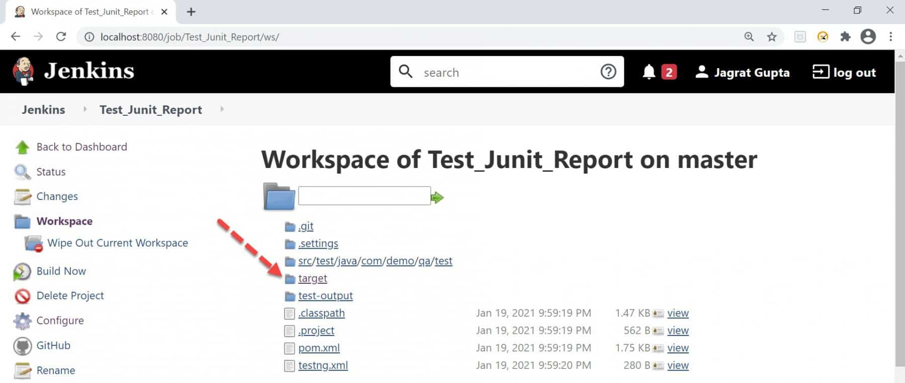

As soon as we click on the above-mentioned link, we will be inside this directory. Now click on the ***"surefire-reports"***  link.

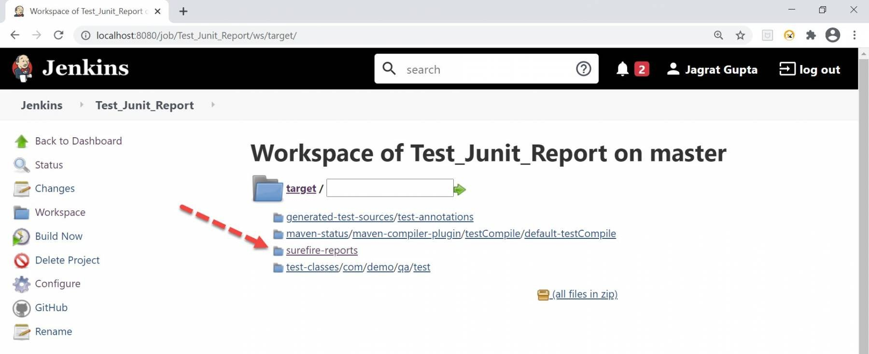

***Step 7:*** As soon as we click on the link mentioned in the previous step, we will be inside this directory. Now, we need to copy the path highlighted in the below image:

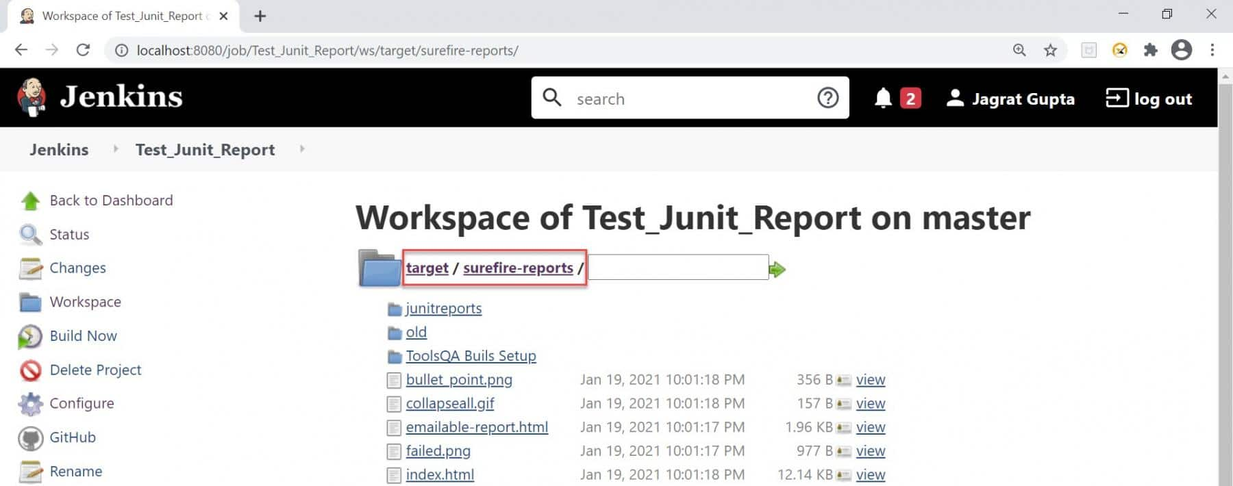

***Step 8:*** Go to Job configuration and move towards the ***"Post Build Actions"***  section. Now do the following steps:

* *Click on the****"Add post-build action"****dropdown.*
* *Select option****"Publish JUnit test result report"****option.*
* *In Test report XMLs textbox, copy the same path following by .xml so complete path would be target/surefire-reports/.xml.*
* *Click on the Save button.*

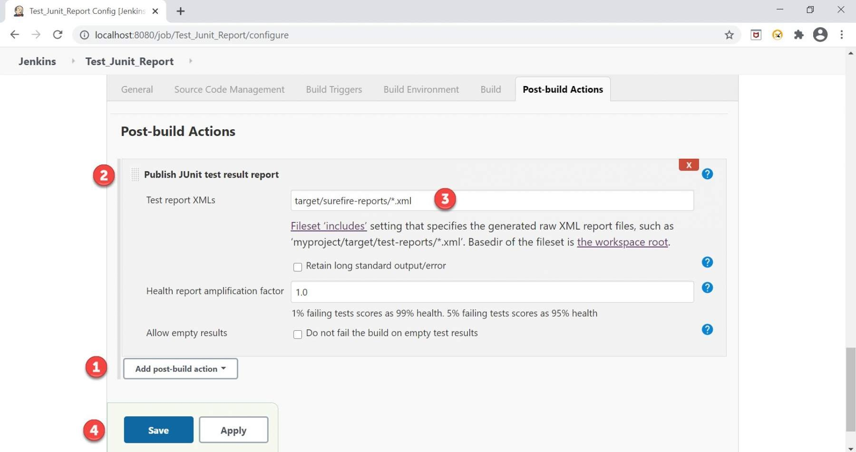

***Step 9:*** Now trigger the build. Once it is completed, go to the respective job, and we can see the new item named ***"Latest Test Results",***  and this is our JUnit Test result report.

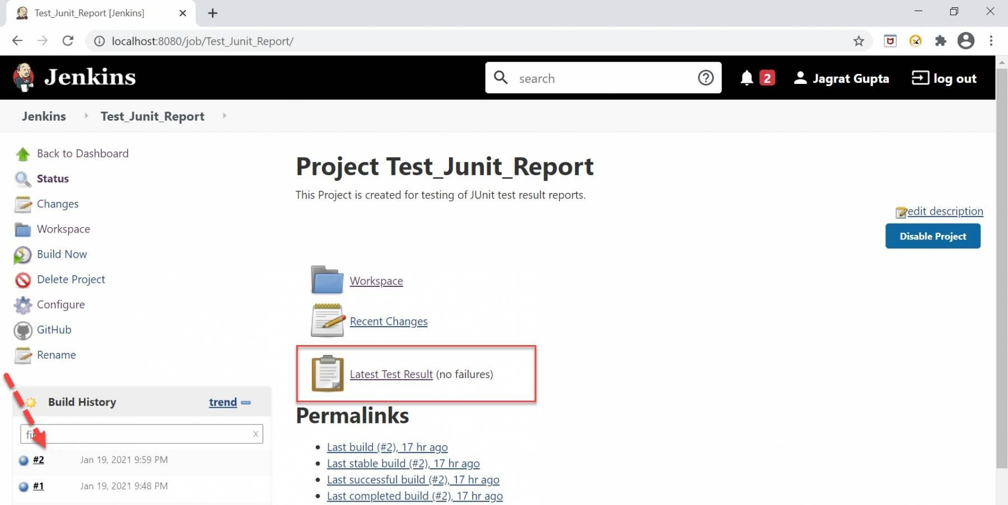

***Step 10:*** We can click on the above highlighted link and see the test results.

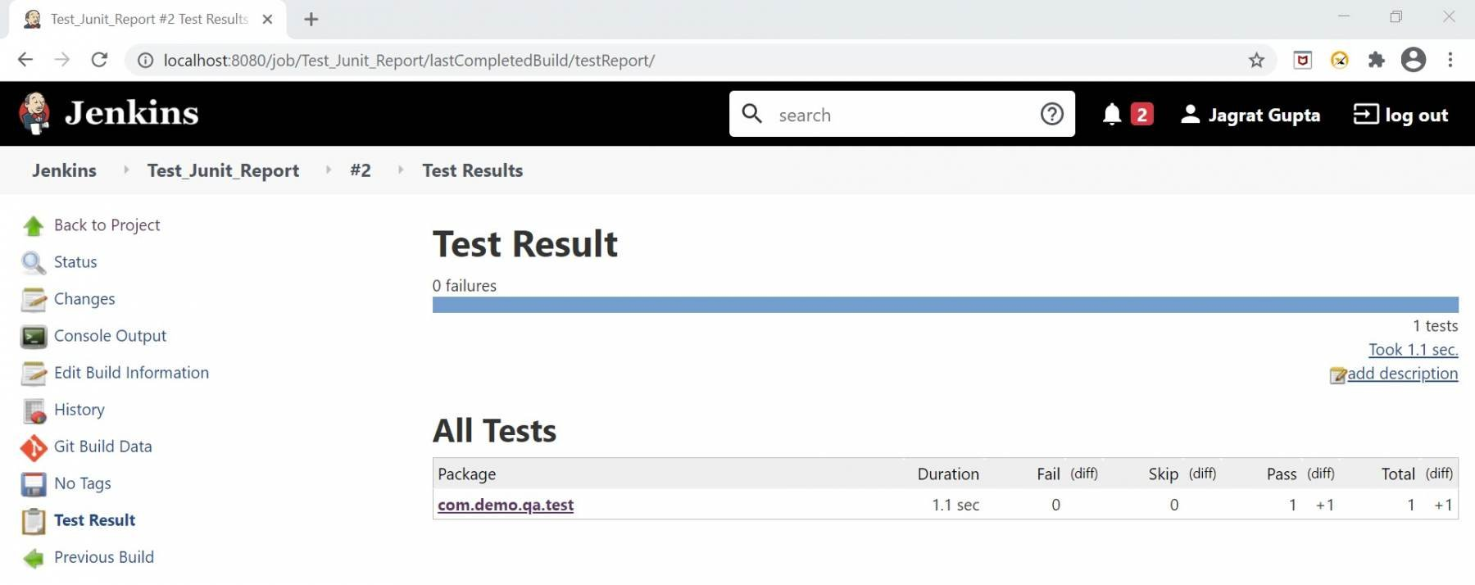

So, in this way, we can publish the *JUnit test result report.* In the next section, let's see one more type of report supported by *Jenkins,* i.e., ***HTML.***

**What is Jenkins HTML report?**

In the previous section, we saw how to publish a ***Jenkins JUnit Report.*** So, in this section, we will talk about another format, i.e., *HTML Report.* The *HTML report* is the better way to represent the test results and can be easily integrated with *Jenkins reporting* capabilities by enabling the HTML reporting plugin. As the name suggests, this report is in *HTML* format and gives us a better look and feel to analyze the results. Let's see in the next subsection what plugin is required in Jenkins to publish *HTML* Report.